Study 2:

**Part 1)**

Human healthy femur:

Cortical material: G=4GPa

Trabecular material: G=13GPa

R2

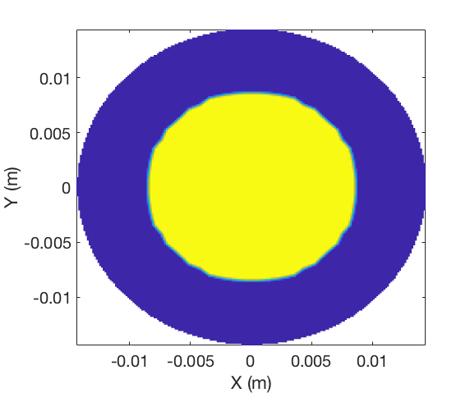1.

R1

R1=8.63mm

R2=14.60mm

Angle of twist per unit length: 0.0010 rad/m

Numerical Torsional rigidity: 362.6740 N.m^2/rad

Total torque: 0.3627 N.m

Max stress resultant: 0.1192 MPa

2.

R2

R1

R0

R1=8.63mm

R2=14.60mm

R0=4mm

Angle of twist per unit length: 0.0010 rad/m

Torsional rigidity: 357.1231 N.m^2/rad

Total torque: 0.3571 N.m

Max stress resultant: 0.1192 MPa

3.

R2

R1

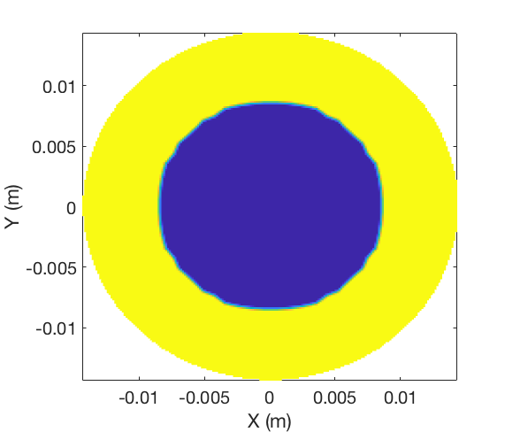

R1=8.63mm

R2=14.60mm

Angle of twist per unit length: 0.0010 rad/m

Torsional rigidity: 249.8702 N.m^2/rad

Total torque: 0.2499 N.m

Max stress resultant: 0.0577 MPa

**Part 2)**

Human femur with fracture:

Cortical material: G=4GPa

Trabecular material: G=13GPa

Fracture angle: pi/6

1.

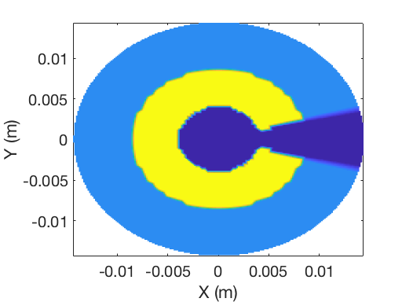

R2

R1

R0

Angle of twist per unit length: 0.0010 rad/m

Torsional rigidity: 324.2828 N.m^2/rad

Total torque: 0.3243 N.m

Max stress resultant: 0.1290 MPa

2.

R2

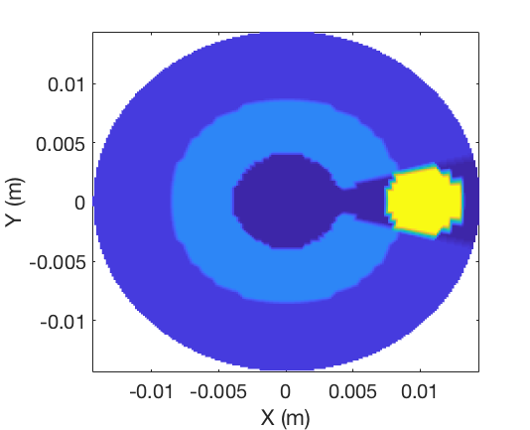

R1

R0

Angle of twist per unit length: 0.0010 rad/m

Torsional rigidity: 442.1075 N.m^2/rad

Total torque: 0.4421 N.m

Max stress resultant: 0.6315 MPa (Steel)

Max stress resultant: 0.50 MPa (Bone)

3.

R2

R1

R0

Angle of twist per unit length: 0.0010 rad/m

Torsional rigidity: 529.3750 N.m^2/rad

Total torque: 0.5294 N.m

Max stress resultant: 0.6309 MPa (Steel)

Max stress resultant: 0.51 MPa (bone)